**LINK:**

[Linking of sheets and dashboard | Tableau Public](https://public.tableau.com/app/profile/chintha.sai.manoj/viz/Linkingofsheetsanddashboard/Dashboard1?publish=yes)

**Sheets:**

Sheet 1:

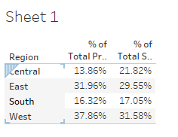

Sheet 2

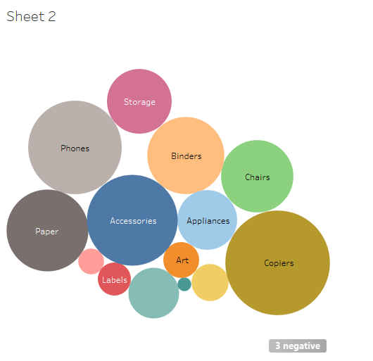

Sheet 3

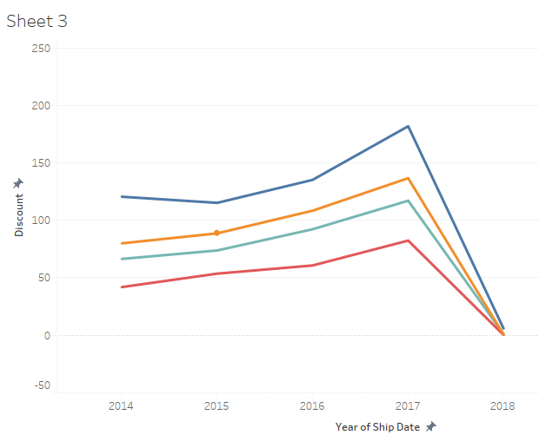

Sheet 4

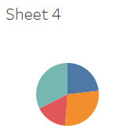

Sheet 5

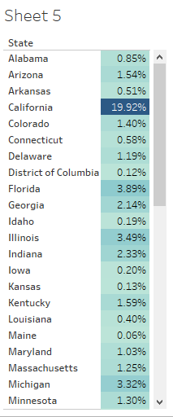

Dashboard

